

Subject: Programming Fundamentals Lab

Submitted to: Madam Iqra Rehman

Submitted by: Muhammad Maaz

Registration no: 24P-3032

Semester: 1st

Department: Software Engineering

**FAST - National University of Computer and Emerging Sciences, Peshawar**

LAB # 08

Question 01:

#include<iostream>

using namespace std;

int main()

{

    int input, factorial=1;

    cout << "Please enter the number you want the Factorial of which: ";

    cin>>input;

    for(int i = input; i>=1; --i)

    {

        factorial = factorial*i ;

    }

    cout<<"The factorial of "<<input<< " is: "<<factorial;

    return 0;

}

Output:



LAB # 08

Question 02:

#include<iostream>

using namespace std;

int main()

{

    int number,table;

    cout<<"Enter the number to get the table: ";

    cin>>number;

    for(int i = 1; i<=10 ; i++ )

    {

        cout<< number <<"*"<< i <<"="<<number*i<<endl;

    }

    return 0;

}

Output:

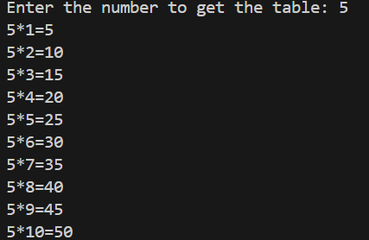

LAB # 08

Question 03:

#include<iostream>

#include<cmath>

using namespace std;

int main()

{

    int a,b; char oper; char d;

    Menu:

    cout<<"Enter 1st number: ";

    cin>>a;

    cout<<"Enter 2nd number: ";

    cin>>b;

    cout<<"Enter the operation as +,-,*,^,s(for square root),%"<<endl;

    cin>>oper;

    switch(oper)

    {

        case '+':

            cout<< "Sum is: "<< a+b <<endl; break;

        case '-':

            cout<<"Subtraction is: "<< a-b <<endl; break;

        case '*':

            cout<< "Product is: "<< a*b <<endl; break;

        case '/':

            cout<<" Division is: "<< a/b <<endl; break;

        case '^':

            cout<< " Exponentiation is: "<< pow(a,b) <<endl; break;

        case 's':

            cout<<" Square root is: "<< pow(a,0.5) <<","<< pow(b,0.5) <<endl; break;

        case '%':

            cout<< " Remainder is: "<< a%b <<endl; break;

    }

    cout<<"Do you want to continue(N for no): "<<endl;

    cin>>d;

    if(d=='n') {return 0;}

    else goto Menu;

return 0;

}

Question: 4

#include<iostream>

using namespace std;

int main()

{

    int a; int total=0;char name; int grade ;

    cout<<"How many student do you want to input: ";

    cin>>a;

    int i = 1;

    for(i = 1; i<=a; i++ )

    {

        cout<<"Enter the name of student" << i <<": "<<endl;

        cin>>name;

        cout<<"Enter "<<name << " Grade:";

        cin>>grade;

        total = total + grade;

    }

    cout<<"Enter the highest grade: ";

    cin>>grade;   //Since user has input grade, he know

    cout<<endl;cout<< "The average grade is: ";   // that what are highest marks. he can input.

    cout<<total/i;

    cout<<"The greatest grade is: ";

    cout<<grade<<endl;

    return 0;

}